Document 2
Quadrennial Report
2019-2022
Sub regions:
Nordic Baltic: 6 National Scout and Guide Fellowships
Denmark, Finland, Iceland, Lithuania, Norway and Sweden
Western Europe: 5 National Scout and Guide Fellowships
Belgium, France (North), Ireland, Luxembourg, The Netherlands and United Kingdom
Central Europe: 11 National Scout and Guide Fellowships
Austria, Czech Republic, Estonia, Germany, Hungary, Latvia, Liechtenstein, Poland, Romania, Slovakia and
Switzerland (North)
Southern Europe: 8 National Scout and Guide Fellowships
Cyprus, France, Greece, Italy, Portugal, Spain, Switzerland (South)
1 Central Branch country: Israel

Conferences – Gatherings - Other
2019
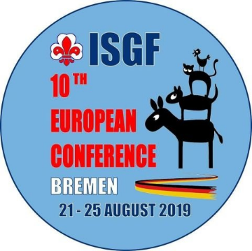
The 10th Europe Region conference was held in Bremen, Germany from 21 – 25 August 2019. One hundred and eighty (180) members from the European member organizations were present with nearly every NSGF / CB in the Region taking part in the conference.
The theme of the conference was "Diversity”.

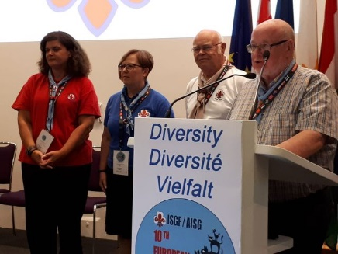
The new elected committee for the triennial 2019-2021 is:
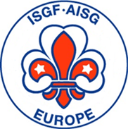

Ana Rodrigues (Portugal) – Public Relations
Lena Claesson (Sweden) - Secretary
Hans Slanec (Austria) - Vice-président
Pierre Decoene (Belgium) – Chairman, treasurer


October 8th 2019 MASCI, the Italian Fellowship with some other European Fellowships and FOCSIV, took the initiative to submit the enclosed appeal to the European Parliament in Brussels.
FOCSIV is the Federation of Christian Organizations International Voluntary Service based in Italy, comprising of 86 organizations that operates in more than 80 countries of the world.

2020
2020 was a strange and difficult year for the entire world. COVID virus brought us a pandemic and the world stopped.
A newsletter was sent to cheer and give a somehow message of hope to all the members of Europe regarding the times we were living.

2021
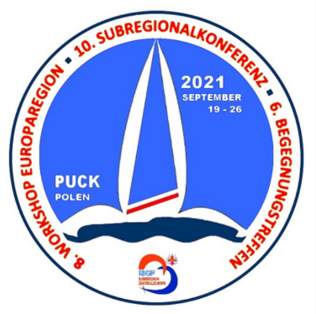
For the first time, the Central European Subregion had invited for three meetings on 19 - 26 September 2021: the 10th Subregion Conference, the 6th gathering and the 8th Workshop of the European Region. The venue was the sailing center of the Polish Scouts in Puck/Poland. This place was the home of more than 40 participants from 8 European countries for seven days. A new board was elected until 2023 – 2026.

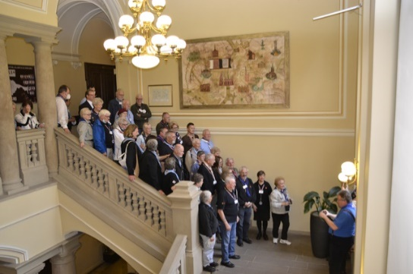
During 2021, several European countries came together to raise donations, food, clothes and other materials and essential goods to send to Ukraine. Central Europe Sub Region had some of its members in the nearby/boarder countries present to help those who were escaping from the war zones.

2022

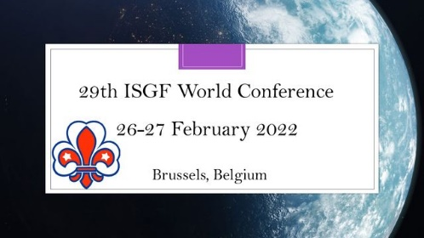
Due to flights/vaccines constrains, it was voted that the 29th World Conference would take place online 26-27 February 2022.
It was by zoom that the Conference took place, having its base in Brussels, where the Secretary-General and members of the World Committee were present to assure transparency in all the process. Three new members were elected to the World Committee:
Prosper Bani - Ghana, Africa
Vanessa Hoogenbergen – Curaçao, Western Hemisphere
Ana Rodrigues – Portugal, Europe

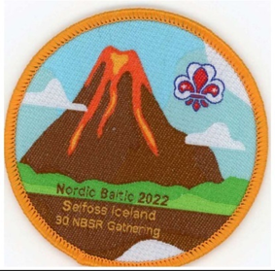
26-30 May NBSR Gathering in Selfoss, Iceland.
During the period of 26th – 30th May 2022, 68 guild members from 8 countries and 10 representatives from the Nordic Scout and Guide Associations gathered in Selfoss in the southwest of Iceland for the 30th Nordic-Baltic Guild Gathering. The gathering was originally scheduled for 2021 but, as we all know too well, the Covid_19 pandemic put an effective stop to that.
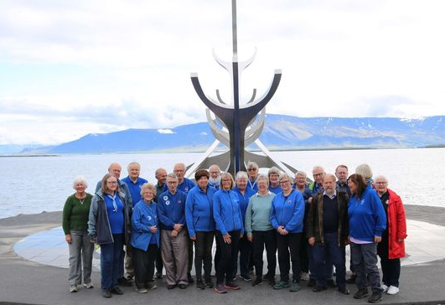

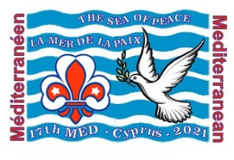
The 17th Med Gathering and 6th South Europe Sub-Regional Gathering took place at Agia Napa, Cyprus, from 24 to 29 October 2022. We had 78 participants from all the Mediterranean area.
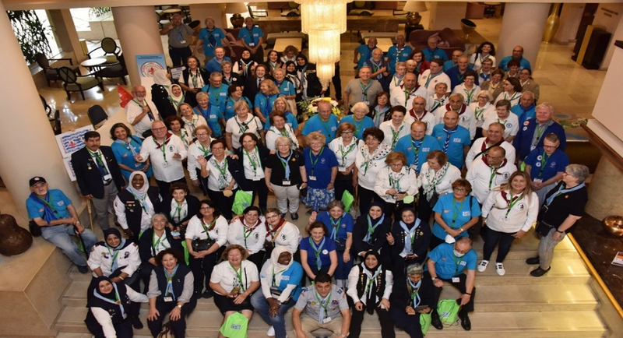

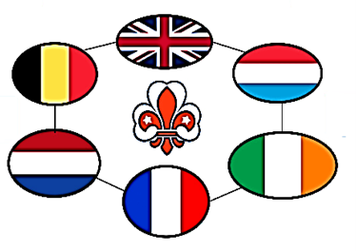

11 September 2022, a Zoom meeting was held for the members of the Western Europe sub-region (WESR). In 2021 there was no sub-regional gathering because of unforeseen circumstances. The BP Guild of United Kingdom took the lead to organize an online meeting for the members.

Meetings

Online meetings :
- 2020 : 6
- 2021 : 5
- 2022 : 5
Main issues
- Finances – fee
- Europe Conference Ranum
- Next Europe Committee transition
- Events
- Money for development
- Help for Ukraine
- Time table
Meeting with the Host Committee for the next Europe Conference April 2022
- I went to Ranum to see the venue
- There are a lot of facilities
- Several meeting rooms and meeting areas
- Secretariat
- Info screens
- Cinema
It was not possible to see the sleeping rooms because a full house and all the rooms were occupied

Newsletters
2020 : 3
2021 : 2
2022 : 5
What is in the newsletters
Information about events and in 2020 the impact of COVID on the events
Information about the Europe Committee : main role, aims
Appeal for help to Ukraine
Best wishes for Christmas, Fellowship day, Thinking day

Region Europe : ways of communication
- Newsletters
- The minutes of each on line meeting
- Financial and auditors rapport each year
All by email to
- National presidents
- International secretaries
Of each country and CB country of the region and the world bureau

Region Europe : Projects

The Europe Committee has no projects but support the projects of the Sub-Region and the Countries.
This can be done by publication in our Newsletter
We also support the host country of the next Europe Conference, even by attending one or more meetings in the host country

