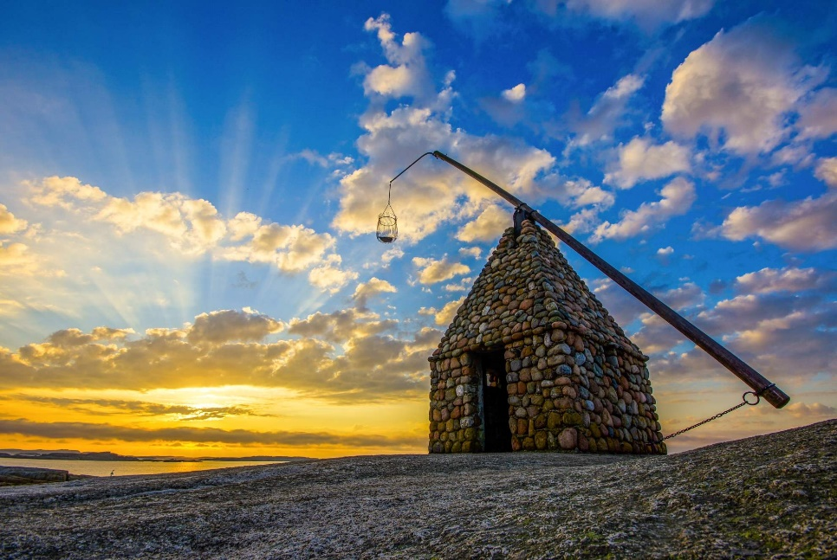

We would like to wish our friends

WELCOME TO NBSR - GATHERING - IN NORWAY
6-9. June 2025

We would like to welcome you to Borge Hotell at Husøy. You can find it near Tønsberg and Nøtterøy, along the west side of the Oslo Fjord. The hotel has an idyllic location and pleasant surroundings, near the sea and has its own pier an beach. There is a heated saltwater pool in the garden and everything is in place for a morning swim before breakfast.
We plan for a varied program, where we have servals exciting lectures. We also plan for quests to have the opportunity to choose between serval different activities that will take plac in the local area round Tønsberg.
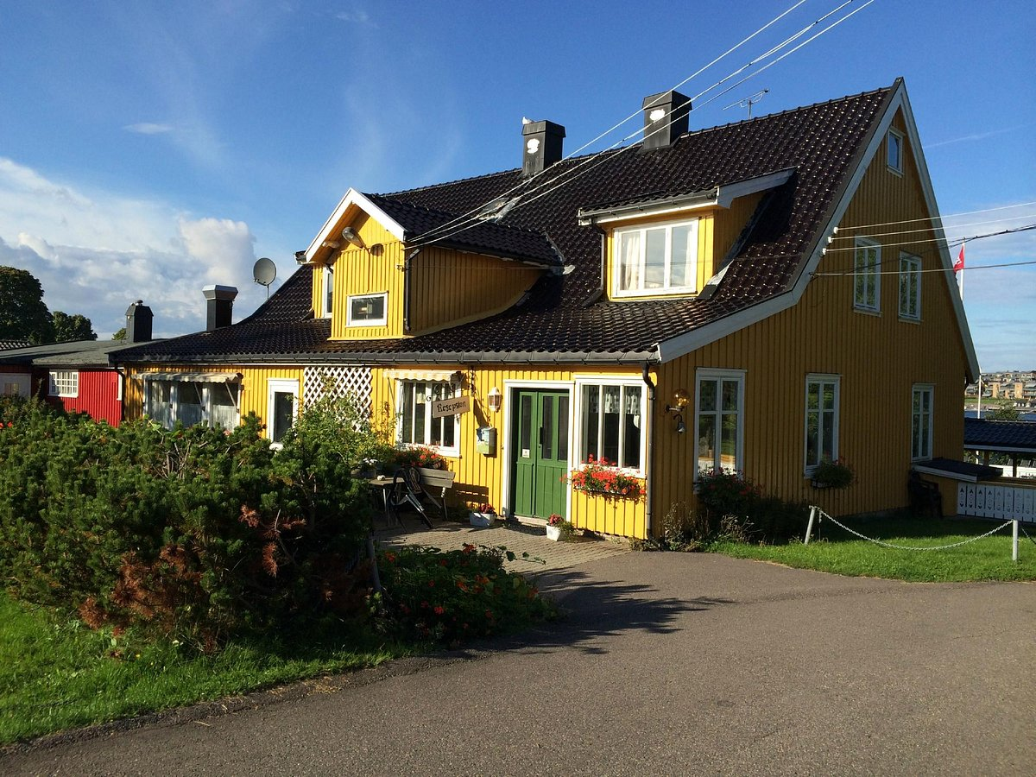

Program for the weekend with the possibility of adjustments:
Friday 06.06.25
15.00 Arrival in Borge Hotel, Check-in
19.00 Diner at Borge Hotel
20.30 Joint program for all

Saturday 07.06.25
07.30 – 09.00 Breakfast
09.30 Official opening
10.15 Official meeting of the NBSR (Denmark responsible)
13.00 Lunch
14.00 Activitys
18.00 Diner with Barbecue
20.30 Campfire
23.00 Evening gathering in Husøy church
Sunday 08.06.25
07.30 – 09.00 Breakfast
10.00 – 15.00 Acticitys
16.00 Nordic Championship in Skotthellekasting
20.00 Gala dinner
Monday 09.06.25
07.30 – 09.00 Breakfast
Checkout
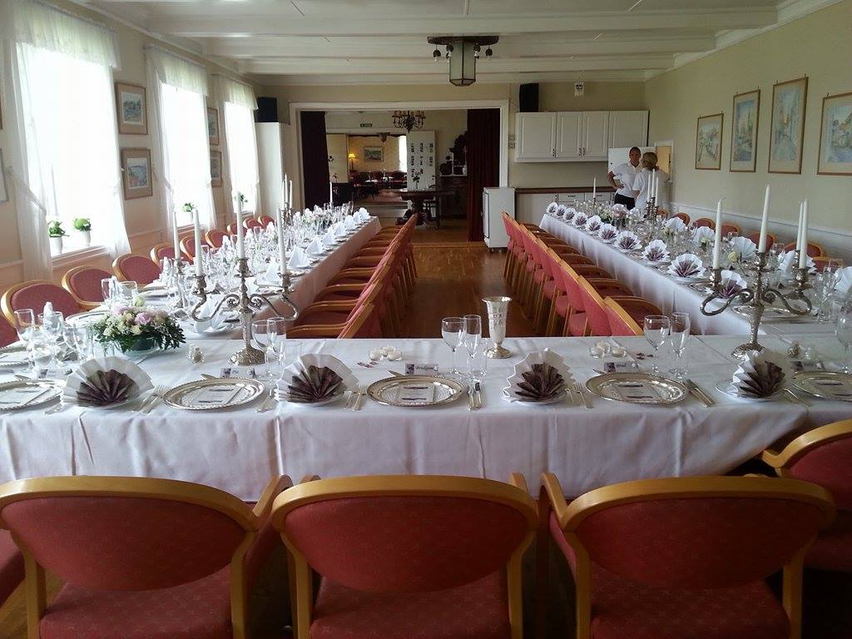

Prices:
Double room: 6790,00 NOK
Singelroom: 7190,00 NOK
Family room in a cabin: 6.190,00 NOK
camper or a tent: 5.340,00 NOK
This covers accommodation, full lodging, and activities. You have to pay for mineral water, wine or beer yourself.
How to get there:
- You can come by car, and in Norway there are good opportunities for charging electric cars.
- You can take the ferry to Larvik, here can you take the train or bus to Tønsberg station. Here you can take the bus to Husøy, or we can pick you up.
- You can take a flight from Copenhagen to Torp, where you can take a train or bus to Tønsberg station. Here you can take the bus to Husøy, or we can pick you up.
- You can fly to Gardermoen where you can take a train directly to Tønsberg station. Here you can take the bus to Husøy, or we can pick you up.
Those of you who come to Tønsberg station and want to be picked up, must let us know when you arrive.
Registration form:

-------------------------------------------------------------- sing up for NBSR meetings in Norway
Name
I want to book accommodation in

Single room
Double room 
Familiy room in a cabin
In your own Camper or tent

I want to share a room with: ___________________________________________________

I am allergic to:

___________________________________________

Send registration form to post@sggn.no within January 15 2025

We will send out invoices - note that you pay the fees to your bank and the Norwegian bank yourself.

Suggestions for tour after the gathering :
Importen to note:
June is a very busy tourist month, with high hotel prices, especially in Bergen.
We would like to propose a possible arrangement is advantaged with accommodation in Voss and I Bergen. Voss is a good starting point for trips to both the Hardanger fjord and the Sognefjord.
A possible suggestion for a trip could be:
Day 1: Tønsberg - Voss (alternative to Flåm) Accommodation in Voss or Flåm
Day 2: "Norway in a nutshell" Voss-Flåm-Gudvangen-Voss. (Alternative Flåm-Gudvangen-Voss). Accommodation in Voss or Flåm.
Day 3: Voss-Bergen. Accommodation in Bergen (Alternative trip to Hardanger with accommodation in Voss)
Day 4: Bergen (or return from Bergen)
Day 5: Return from Bergen

There is a daily ferry from Bergen (13.30) with arrival in Hirtshals the next morning)

